REQUEST FOR PROPOSALS

2019 CATHOLIC CAMPAIGN FOR HUMAN DEVELOPMENT
LOCAL GRANTS

Deadline for Submission: January 31, 2019

The Parish Social Ministries Office of Catholic Charities Eastern WA announces solicitation of grant applications for the distribution of the local portion of this year’s Catholic Campaign for Human Development (CCHD) funds. The Campaign, established in 1970 by the National Conference of Catholic Bishops, is the U.S. Catholic Church’s education/action program to combat domestic poverty by addressing root causes through community organizing and economic development.

CCHD Criteria and Guidelines:

- The project must benefit a poverty group and/or address the underlying causes of poverty.

- Members of the poverty group in question must have a significant involvement in the project through active participation in its inception, operation and/or management.

- The project must demonstrate a capability to combat the basic causes of poverty and/or to affect institutional change.

- The project activity and sponsoring agency must conform to the moral teachings and philosophy of the Roman Catholic Church.

- The applying organization must be a nonprofit corporation or be sponsored by a nonprofit corporation.

Projects Generally NOT meeting CCHD Criteria and Guidelines:

- Projects that primarily provide direct services to low income people, such as:
Emergency assistance programs, day care centers, recreation programs, community centers, scholarships, subsidies, counseling programs, referral services, cultural enrichment programs, direct clinical services, emergency shelters and other services, refugee resettlement programs, etc.

- Projects operated and managed by government (federal, state, local), educational or ecclesiastical bodies.

- Projects sponsored by organizations currently receiving substantial sums from other funding agencies, unless the applicant documents that this particular project cannot be funded by these agencies.

- Projects that have already received funding for three consecutive years.

Applicants should submit a concisely worded written proposal, with seven (7)copies, printed on 8 ½ x 11 paper, containing the following elements:

- Title page: proposed project title, name of organization, address, telephone, and contact person.
- Description of organization.
- Brief description of project, its goals and objectives.
- A description of the way in which participants are involved in and benefit from this project.
- An itemized budget of project including specific use of CCHD funds and other sources of funding.
- A copy of your organization’s budget for the current fiscal year and a year-end financial statement for the previous fiscal year.
- Proof of nonprofit status or that of sponsoring agency.
- List of Board of Directors, their addresses and occupations.

Grants are typically in the range of $1,000 - $4,000 and will be released in spring, 2019.

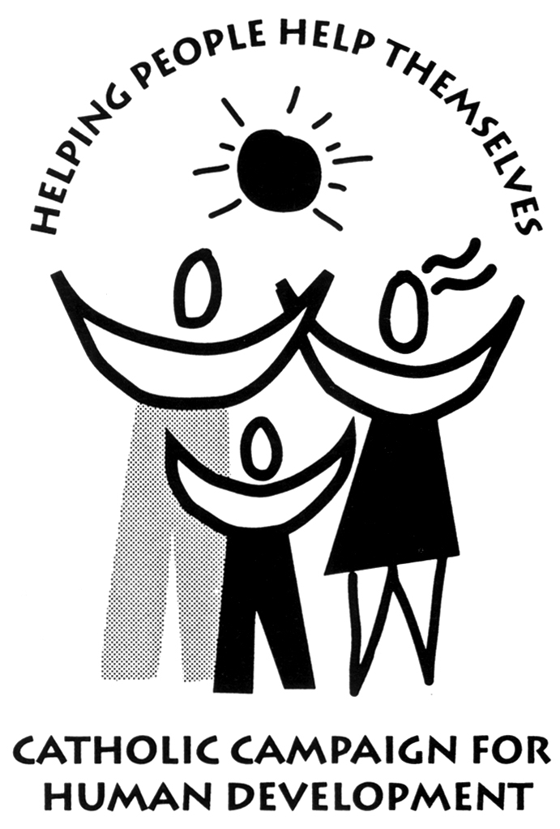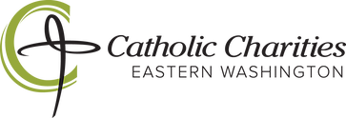

Applications mailed to: Connie Smith For more info: Scott Cooper
Diocesan CCHD Coordinator Catholic Charities
2415 S. Katy Ct. (509) 358-4273
Spokane WA 99224 (509) 939-9428 (800) 831-1209

